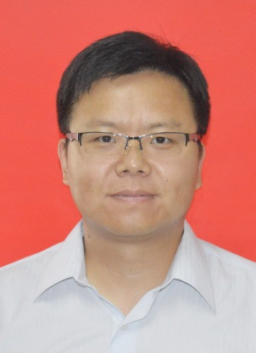
Research Interests:
Semiconductors, Graphene materials and nanomaterials, Organic/perovskite solar cells, Electronic and optoelectronic devices
School: Guilin University of Electronic
Technology
Education: Doctor
Phone: 13188888888
E-mail: 123456@qq.com
ZHANG Jian Xiaolin

Phone: +86-773-2201629
Education background
Experience
Papers
Awards
E-mail: jianzhang@guet.edu.cn
.com
1. 2004: Postdoctoral grant for young researchers from foreign countries (selective), French Ministry of Research
2. 2004: Alexander von Humboldt Fellowship, Alexander von Humboldt Foundation, Germany
3. 2009: 100-Talents Program, Chinese Academy of Sciences, PR China
4. 2014: Bagui Scholarship, Guangxi, PR China
Education background
1999.9–2004.6 Ph.D. in Polymer Physics and Chemistry, Changchun Institute of Applied Chemistry, Chinese Academy of Science.
1995.9–1999.6 B.S. in Chemistry, Xiangtan University.
2014-present College of Material Science and Technology, Engineering Research Center of Electronic Information Materials and Devices of Ministry of Education, Guilin University of Electronic Technology, Professor;
2009-2014 State Key Laboratory of Catalysis, Dalian Institute of Chemical Physics, Chinese Academy of Sciences, Professor;
2005-2009 Humboldt University Berlin, Berlin, Germany;
2004-2005 Laboratoire des Matériaux Moléculaires et des Biomatériaux (LMMB), UMR CNRS 6114, Marseille, France；
1999-2004 Changchun Institute of Applied Chemistry, Chinese Academy of Sciences.
Experience
Publications

1. Guanshui Xie, Zheling Zhang, Zhenying Su, Xiaoling Zhang, Jian Zhang*. 16.5% efficiency ternary organic photovoltaics with two polymer donors by optimizing molecular arrangement and phase separation, Nano Energy 69 (2020) 104447.
2. Jian Xiong*, Zhongjun Dai, Shiping Zhan, Xiaowen Zhang, Xiaogang Xue, Weizhi Liu, Zheling Zhang, Yu Huang, Qilin Dai*, Jian Zhang*. Multifunctional passivation strategy based on tetraoctylammonium bromide for efficient inverted perovskite solar cells, Nano Energy, 2021, 84, 105882.
3. Miao Zhang, Fujun Zhang*, Qiaoshi An, Qianqian Sun, Wenbin Wang, Xiaoling Ma, Jian Zhang*,Weihua Tang. Nematic Liquid Crystal Material as Morphology Regulator for Ternary Small Molecule Solar Cells with Power Conversion Efficiency Exceeding 10%, J. Mater. Chem. A 2017, 5, 3589.
4. Jian Liu, Dongjie Wang, Kun Chen, Bin She, Baichen Liu, Yu Huang, Wenfa Xie, Jian Zhang*, and Hailiang Zhang*. Improved Pore-Filling and Passivation of Defects in Hole-Conductor-Free, Fully Printable Mesoscopic Perovskite Solar Cells Based on D-Sorbitol Hexaacetate-Modified MAPbI3, ACS Appl. Mater. Interfaces 2020, 12, 47677−47683.
5. Jibin Zhang, Louwen Zhang, Ping Cai, Xiaogang Xue, Mingkui Wang, Jian Zhang*, Guoli Tu*. Enhancing stability of red perovskite nanocrystals through copper substitution for efficient light-emitting diodes, Nano Energy 2019,62, 434-441.

